**Question 1 1. Add a 10GB disk to the CentOS.**

**2. Create 2 Partitions 4GB and 6GB of Space respectively.**

**3. Format 4GB with xfs and 6GB with ext4 file system.**

**4. Mount 4GB and 6GB in /data and /music directory respectively.**

**5. Create one file of 1GB in each of the mount point created above.**

**6. Verify the disk Consumption and disk space free in the mounted partitions.**

**Answer**

I took screen shot of disk drives before adding 10 gb hard disk to the system as below

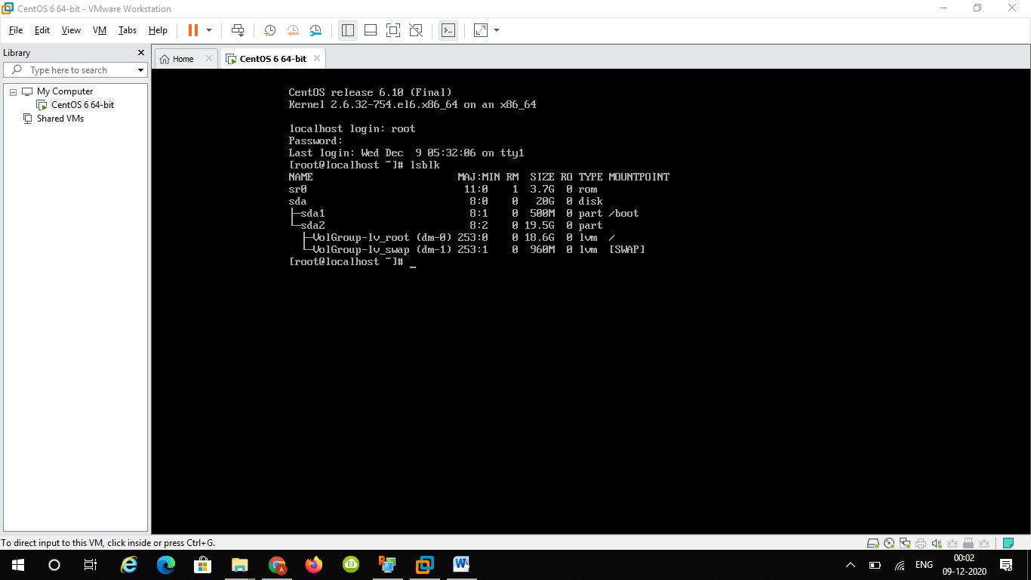

1. I opened settings tab

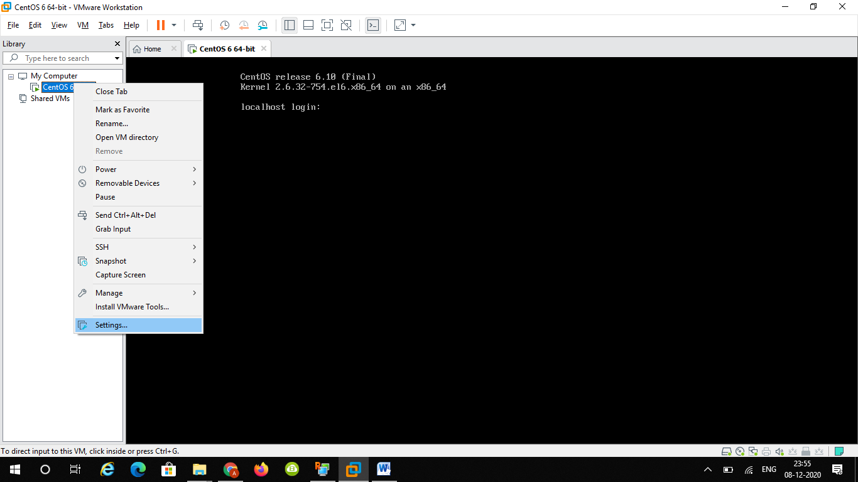

Then I saw the below settings

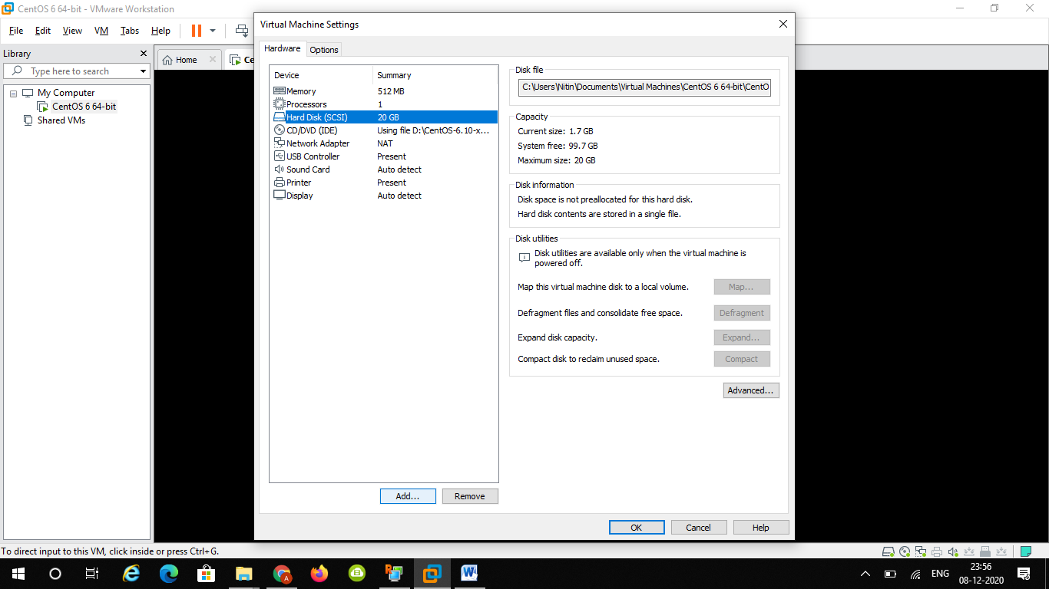

I clicked on add hard disk then wizard opened to select and add hardware

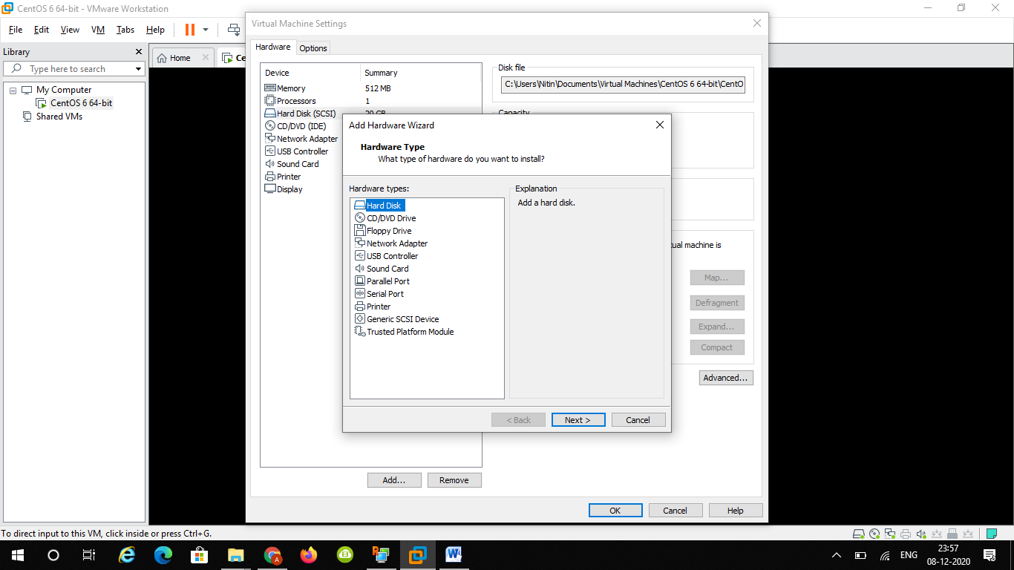

Selected hard disk drive and clicked next

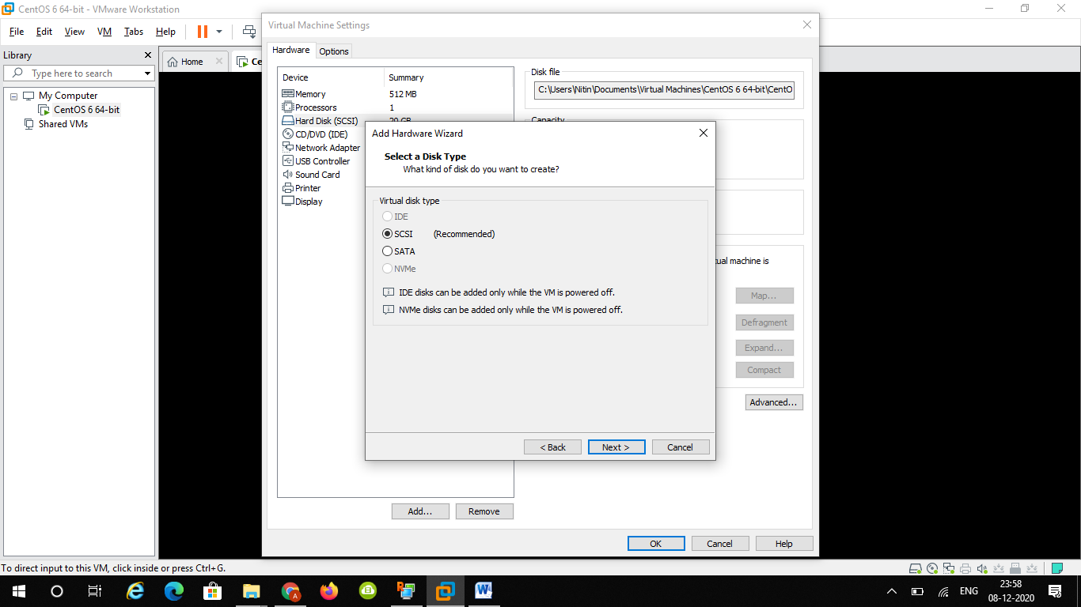

I haven’t changed anything here ..just clicked next

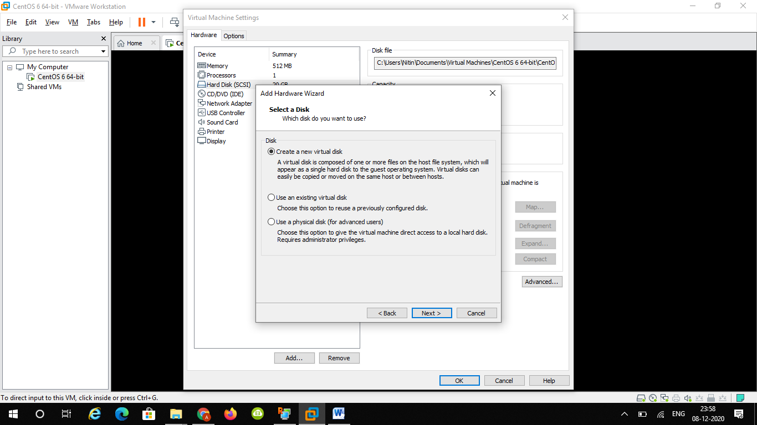

Clicked on create new virtual hard disk drive

I gave it size of 10 GB and selected single file.

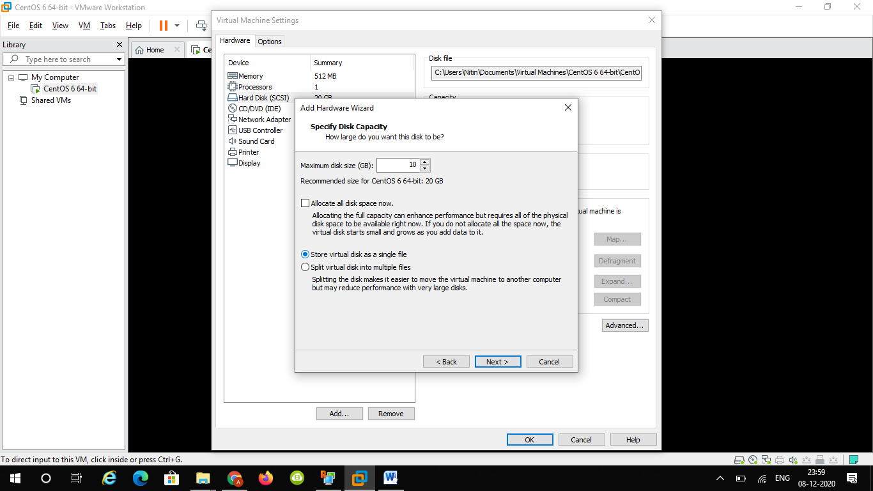

And gave it name and clicked finished

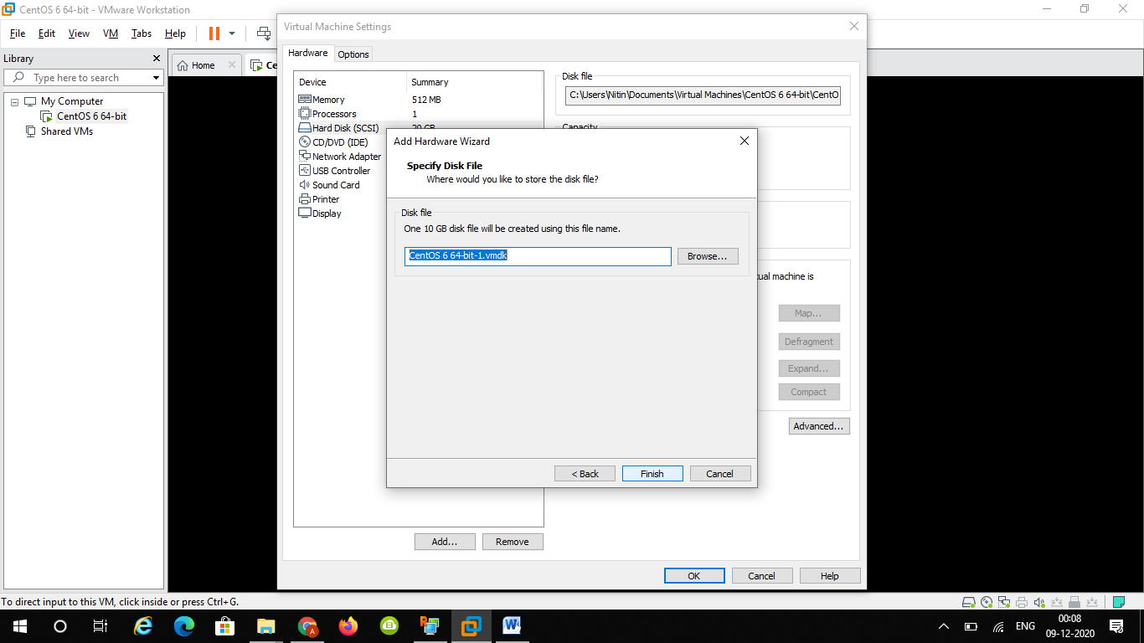

Now I can see 10gb disk as sdb as below

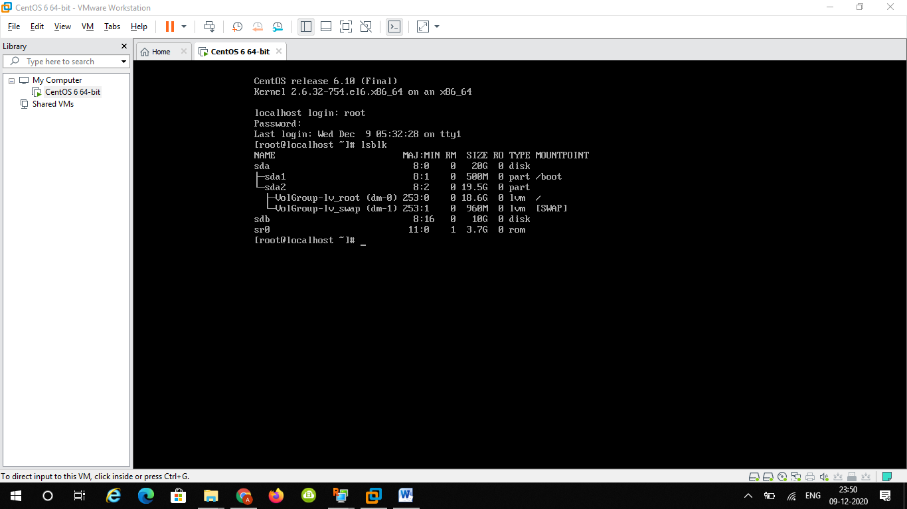

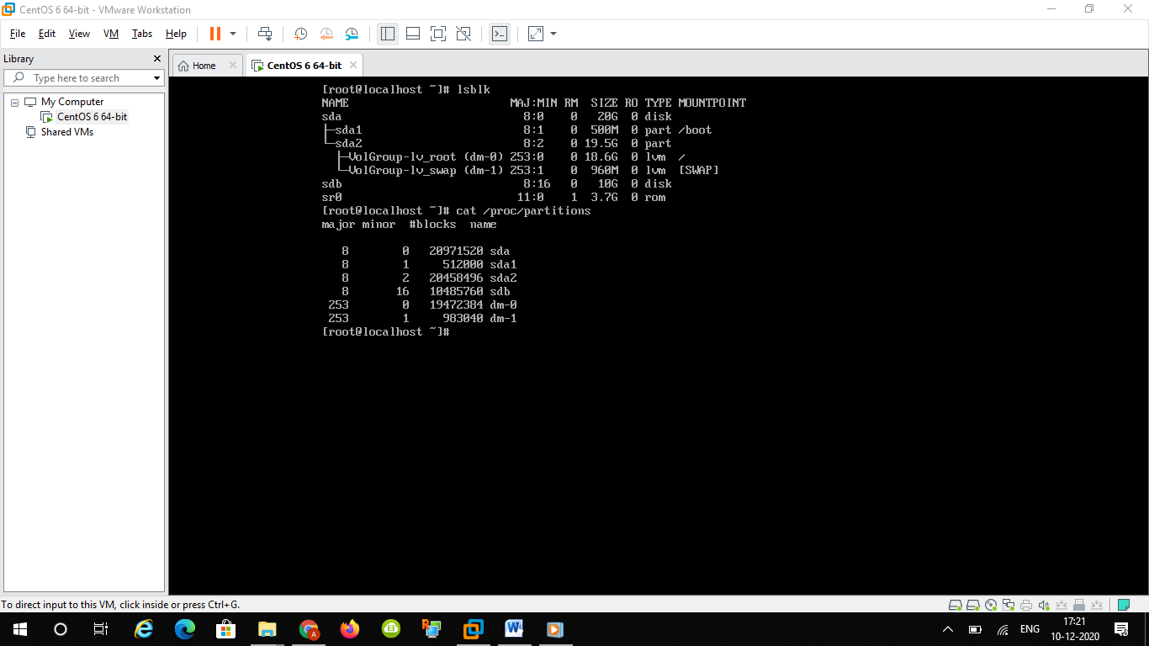

Step 2

Creating two partions as 4GB & another 6 GB

First of all selected sdb hard disk as below

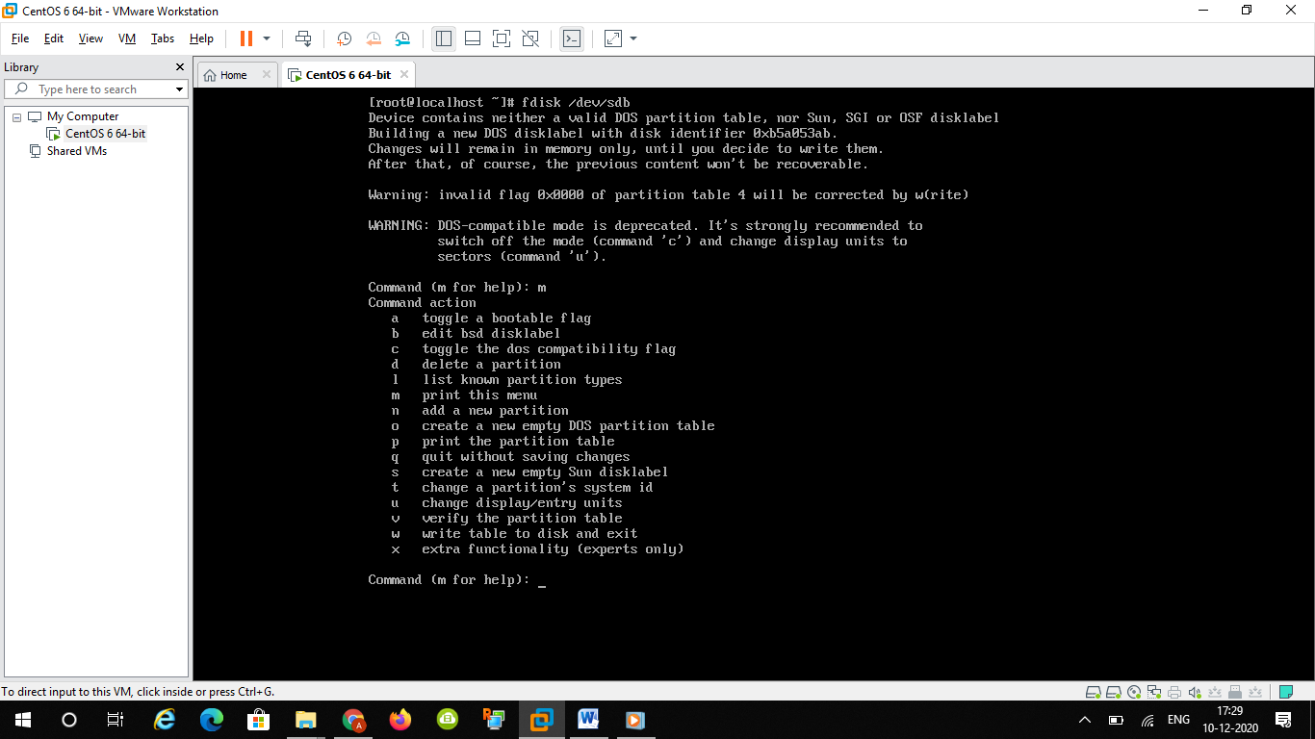

Below is output to create both partitions as primary

Created first primary partitoin of 4 gb as primary as below

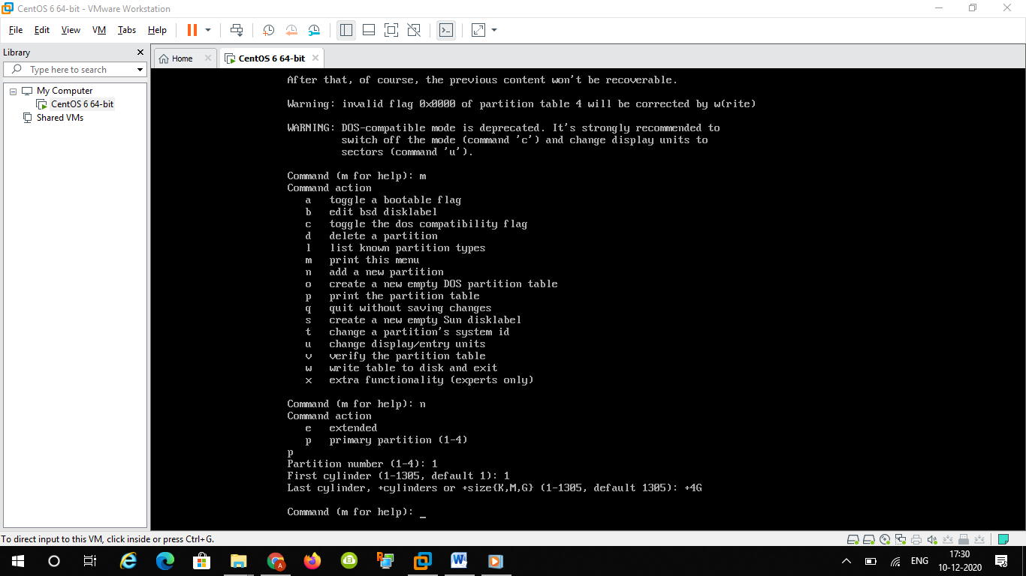

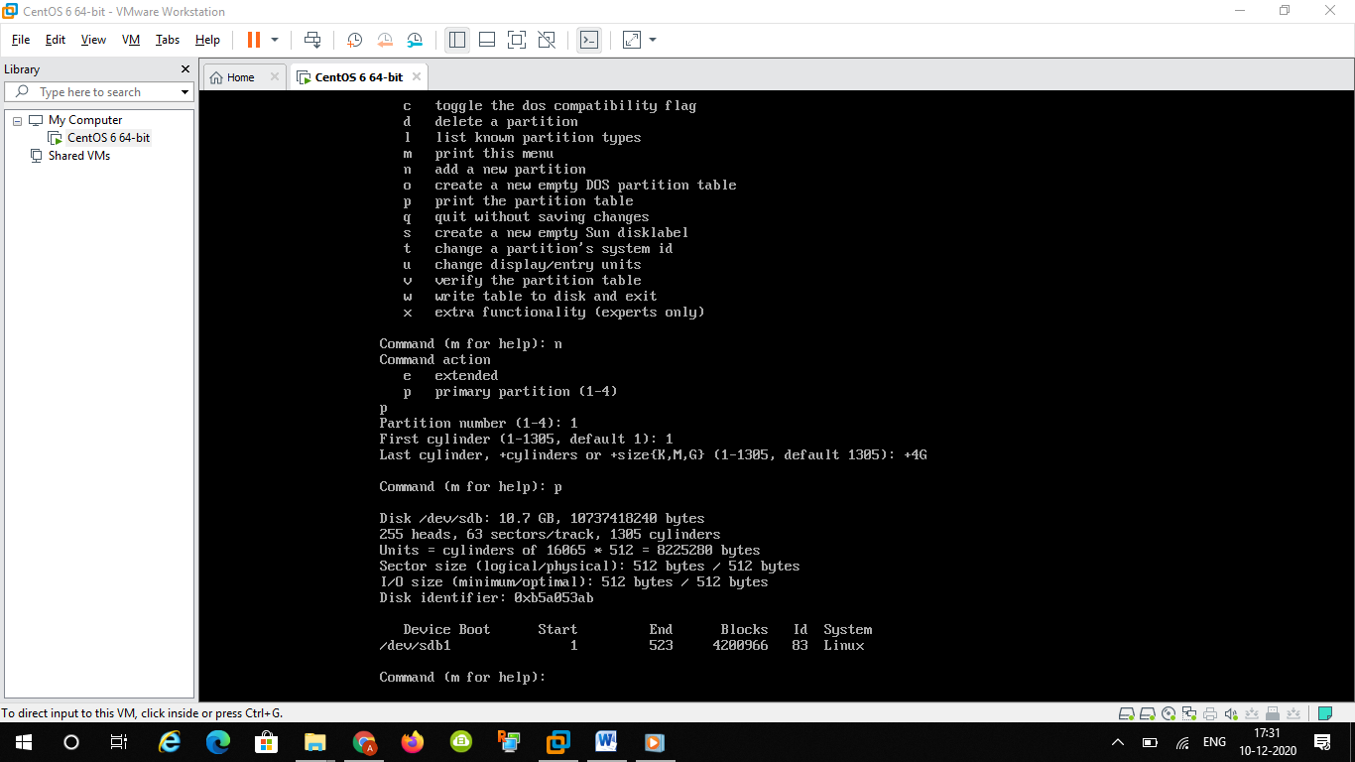

Rest of the 6 gb partitions created as primary as below

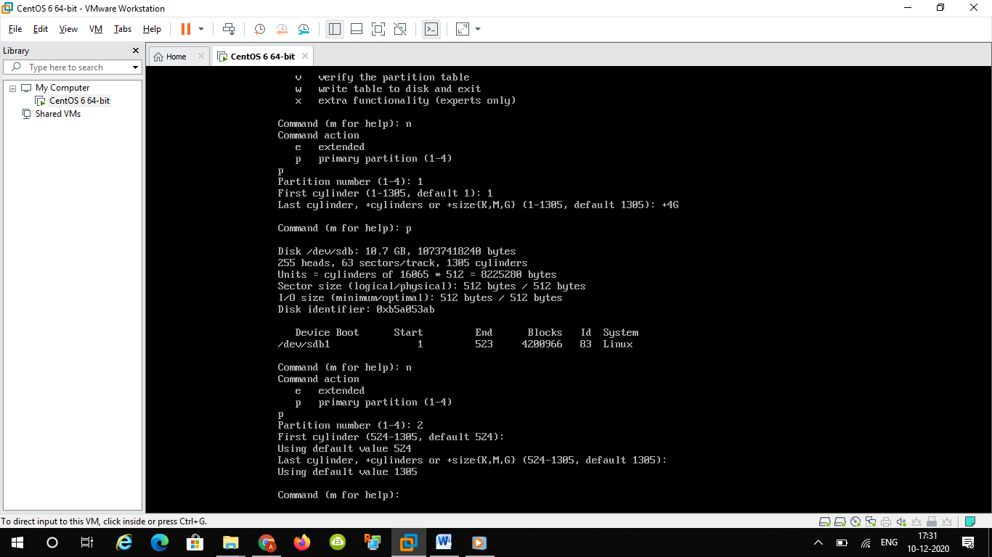

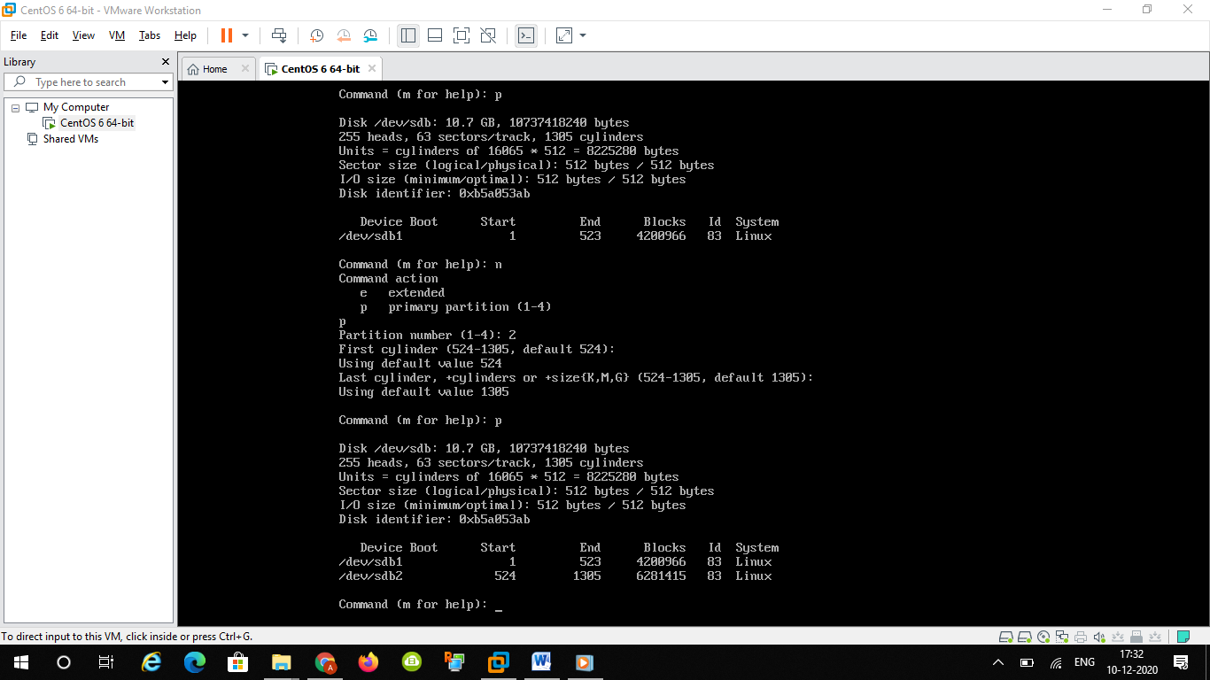

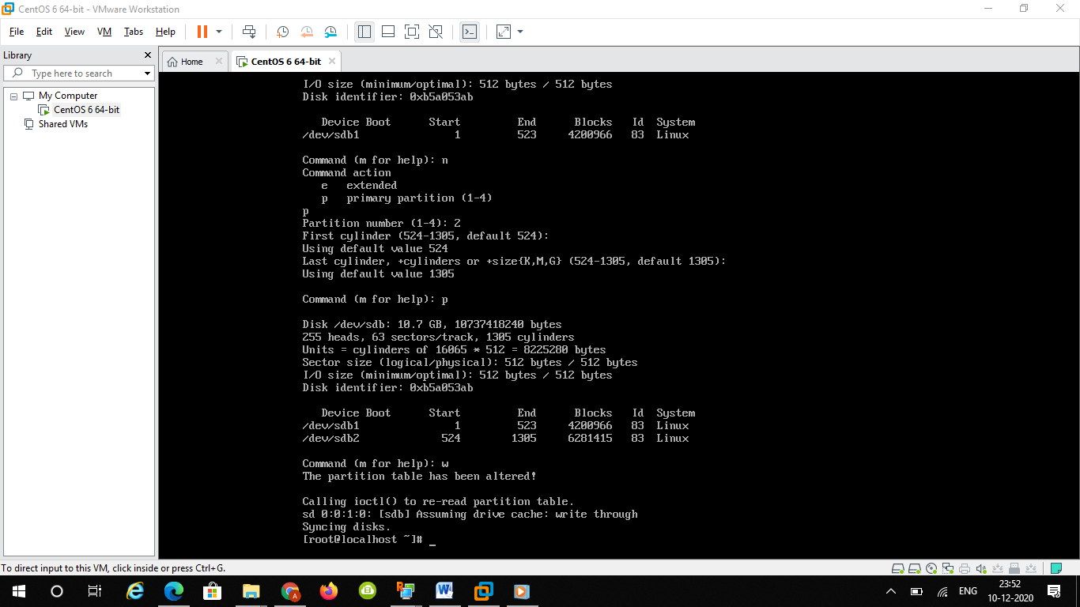

Step 3

Bydefault xfs file system not available in centos6

So I installed using command yum

Initially iso added to cd/dvd drive like below

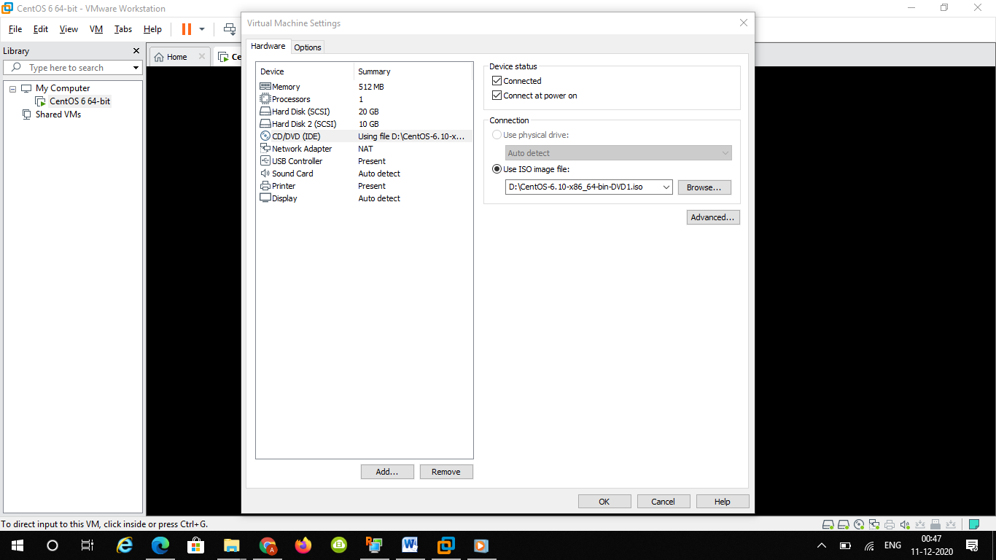

After that created made direcotry of /dvd and mount cdrom to it

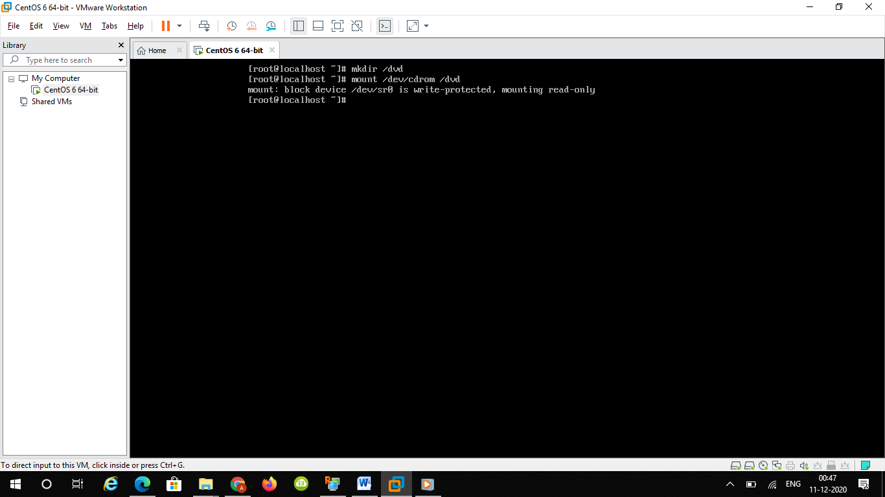

After that created repolist mycentos6.repo

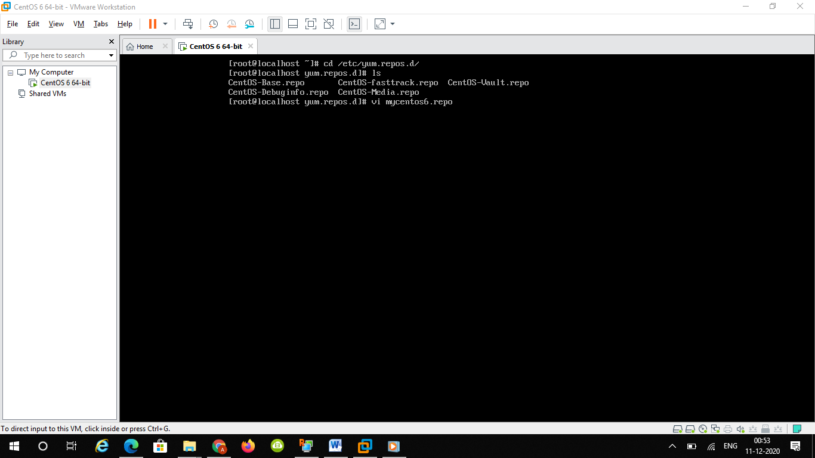

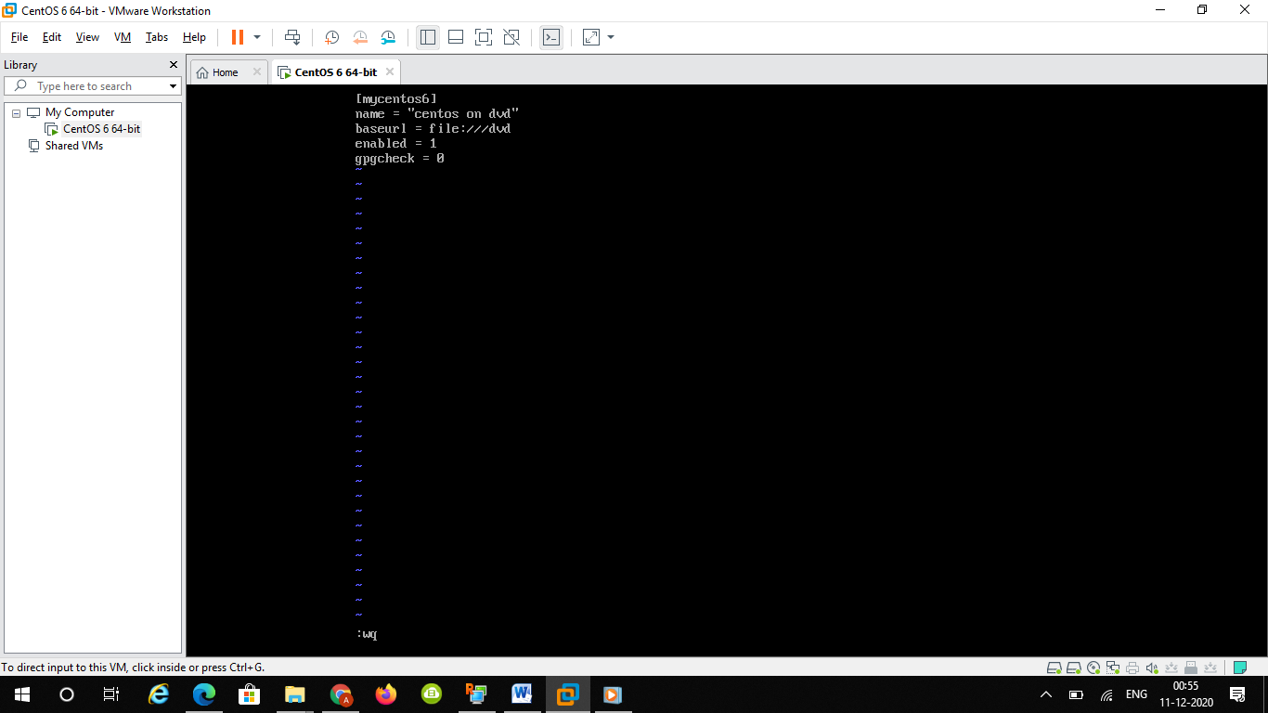

And can see my repository as below

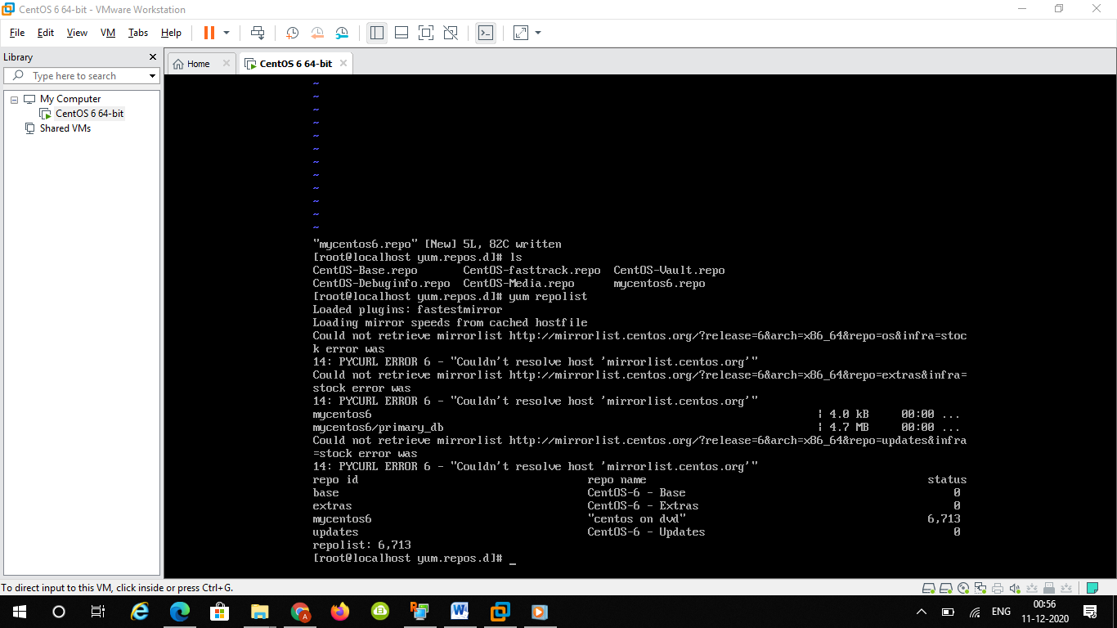

Installed xfsdump using yum

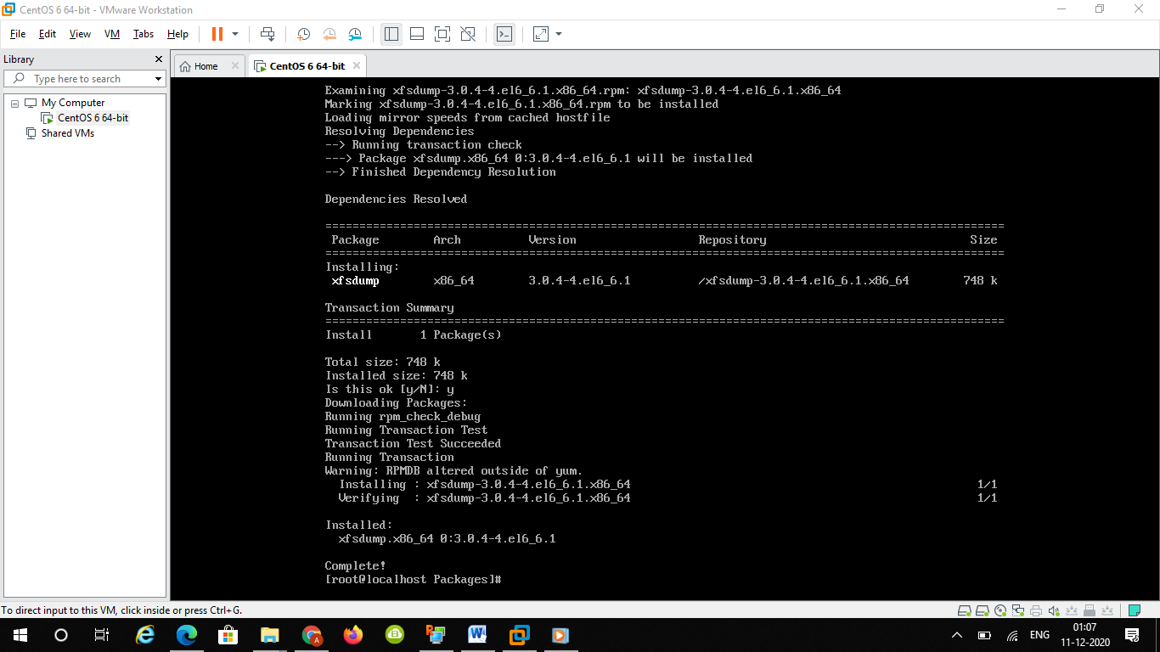

Formatted first 4gb drive as xfs file system as below

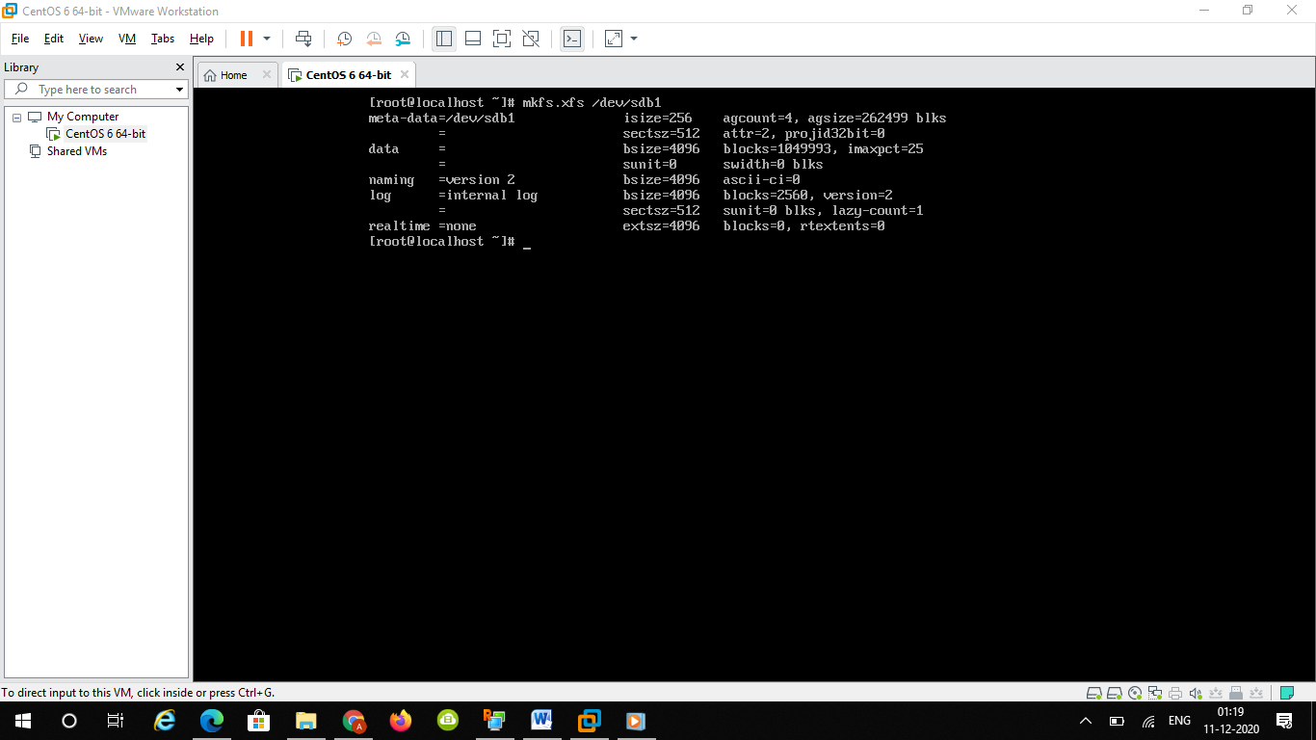

After this formatted secong 6gb drive as ext4 as below

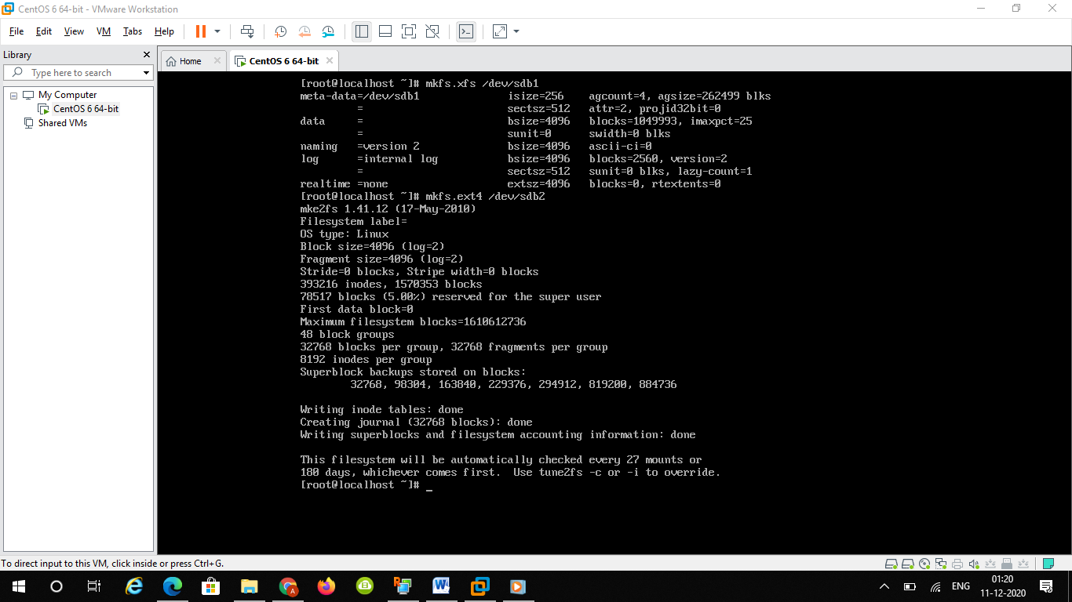

Step 4

Created mount point and mount sdb partitions to it as below

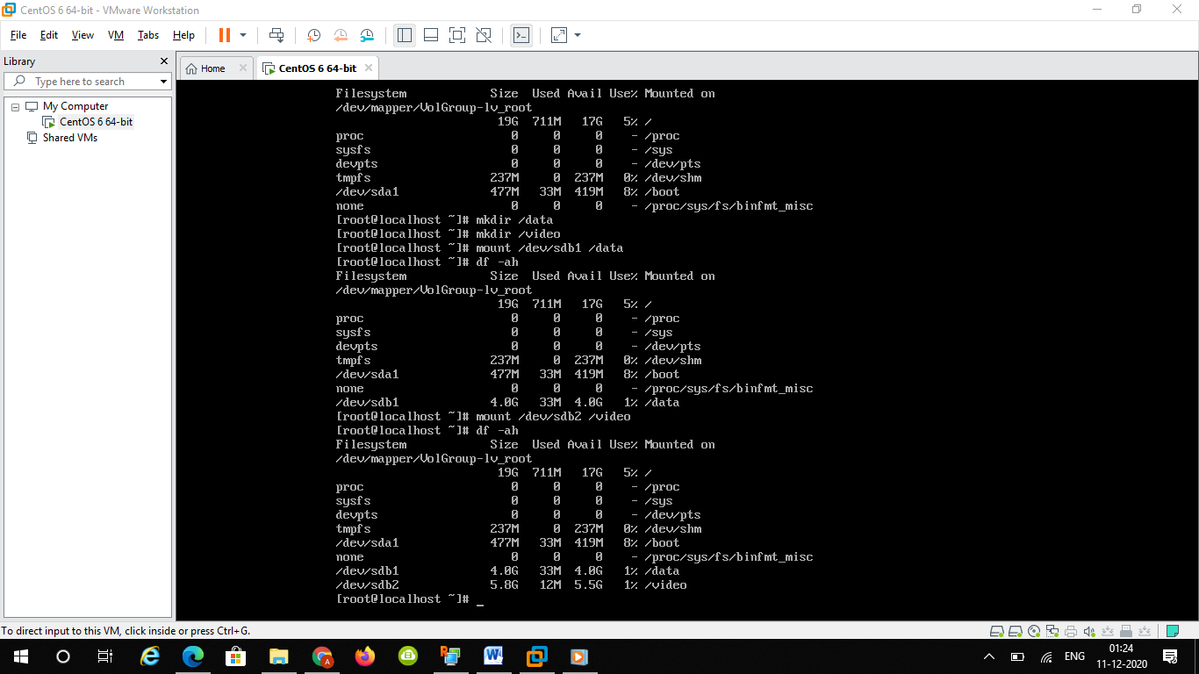

To view both mount point command mount is used

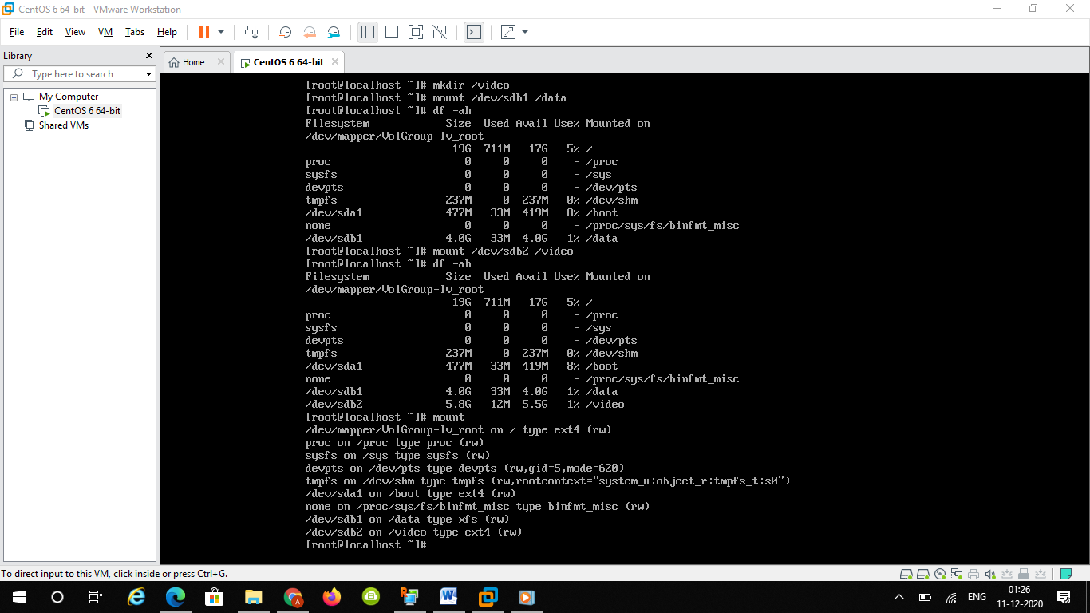

To make permanent available mount points just did the below

Vi /etc/fstab

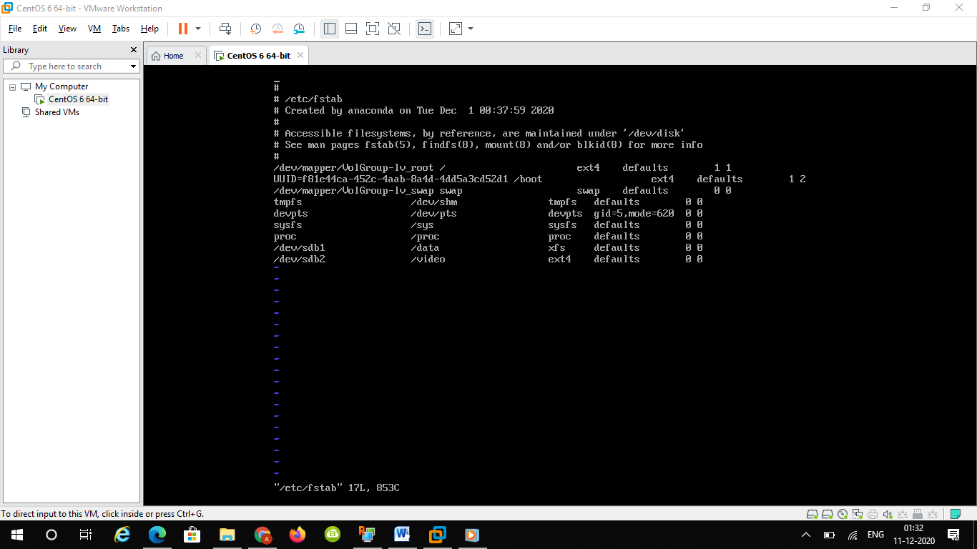

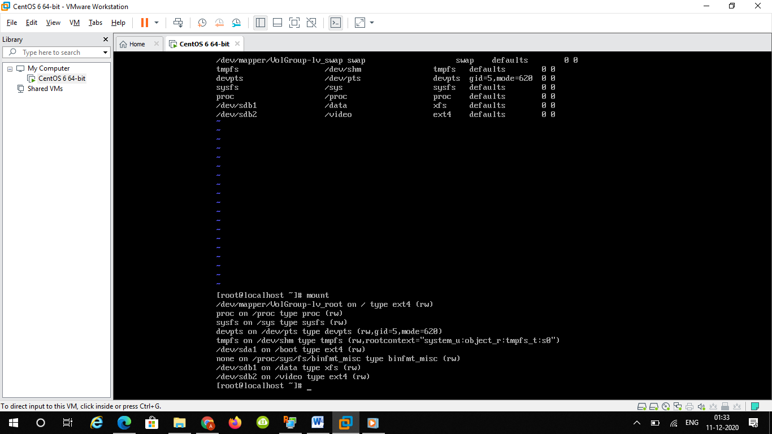

Step5 :

Below is the disk utilization before creating 1 gb file into the partitions

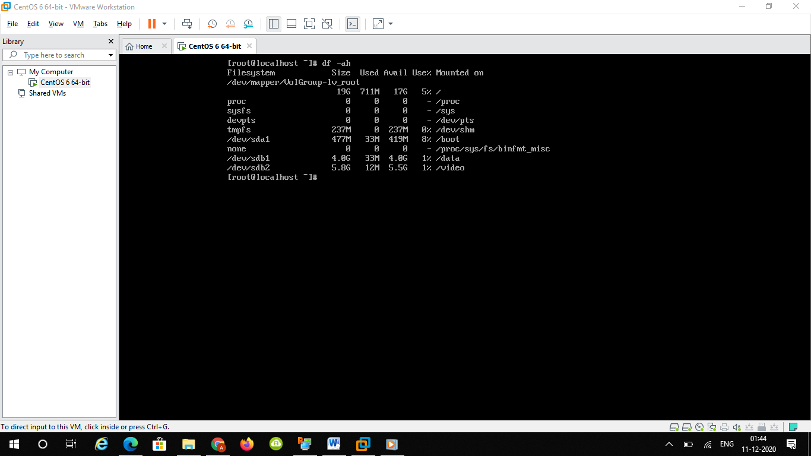

And after creating files on /data below is the output

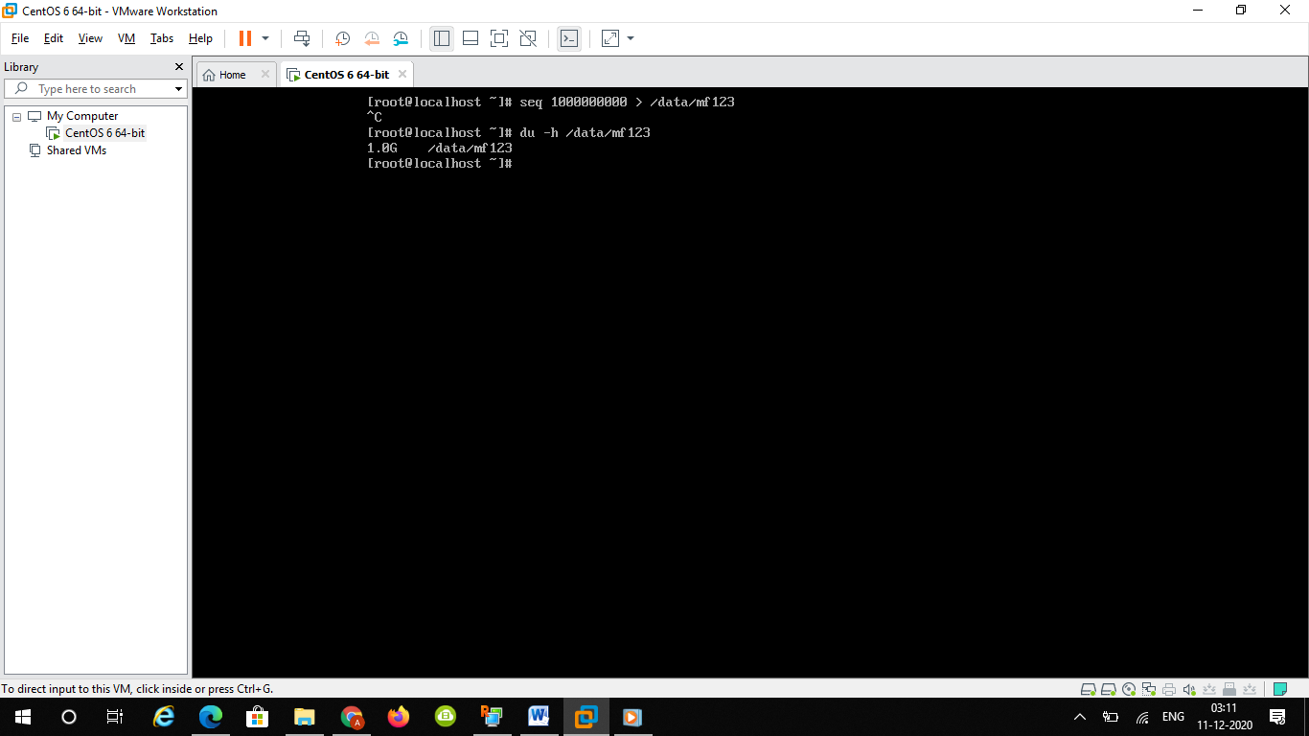

And after creating files on /video below is the output

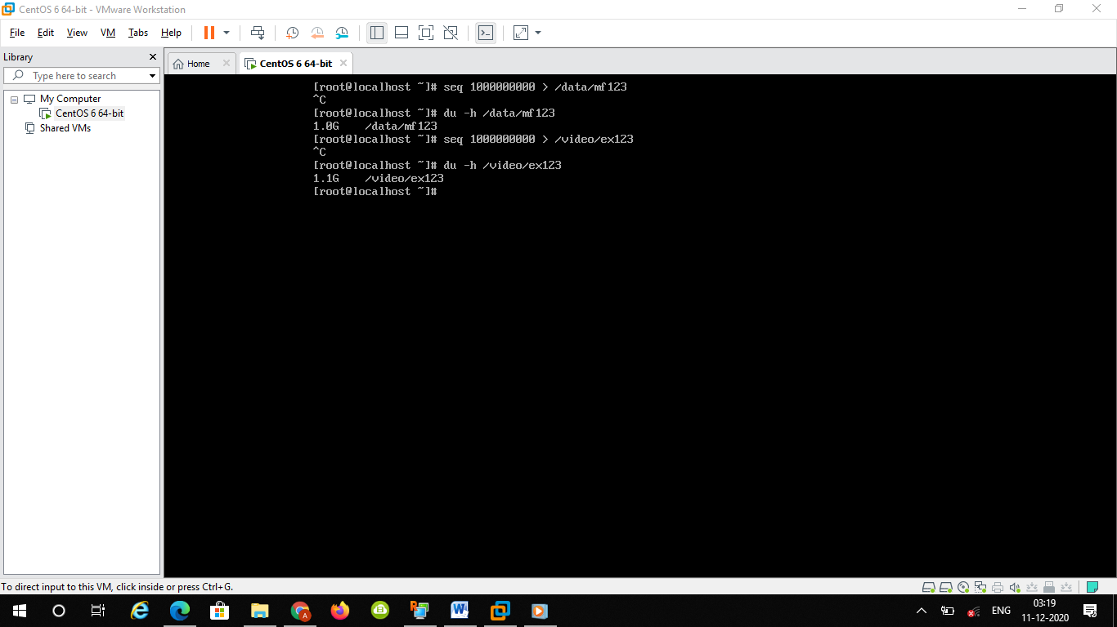

Step 6 : verify space using df –ah

